RIPHAH INTERNATIONAL UNIVERSITY


Faculty of Computing
Object Oriented Programming Lab
Lab 1
Submitted By: Khadija Binte Asif
SAP ID: 77954
Submitted To: Miss Nayab Khalid

Supervision and Coordination

Shazwa Tun Naeem
Lecturer
Faculty of Computing

Lab Designers

Nayab Khalid
Teaching Fellow
Faculty of Computing

7. Lab Exercise & Demo

Lab Task 1 — Calculate Average
Create a function float calculateAverage(int arr[], int size) that receives an integer array and its size and returns the average of its elements. In main(), ask the user for the number of elements, validate that it is positive, input the elements, call the function, and display the average.

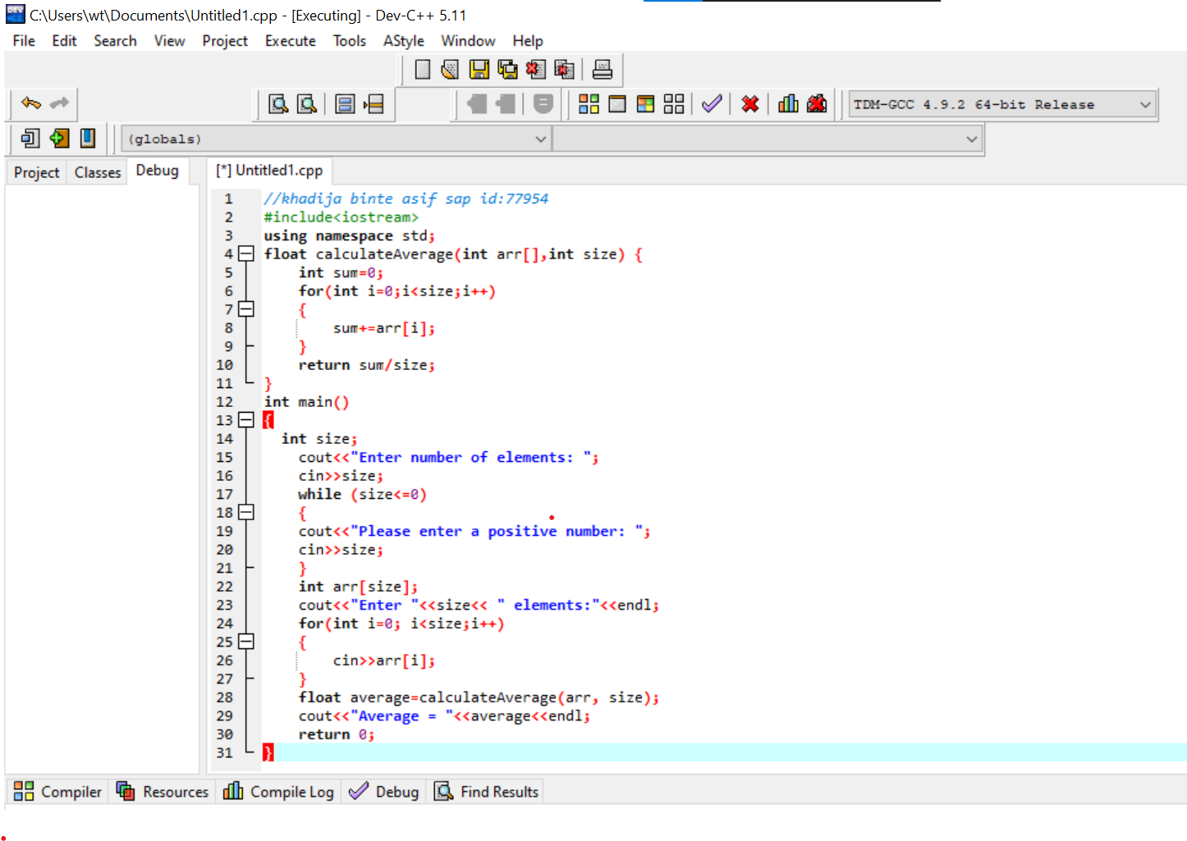
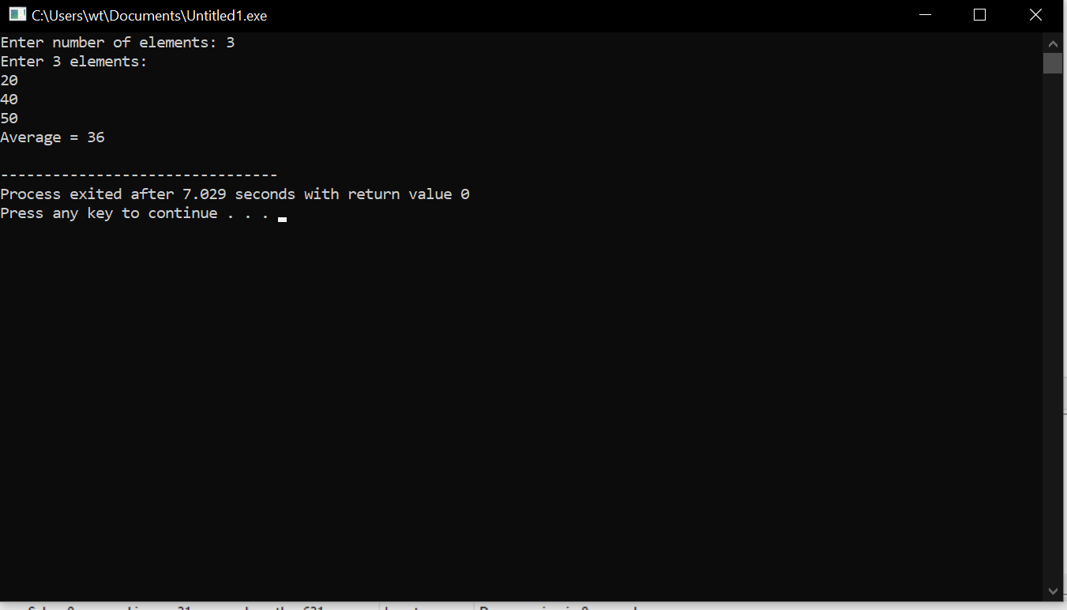

Lab Task 2 — Student Records
Define a Student struct with string name, int rollNumber, and float marks. Create an array of three Student structs, input the information for each student, and display all records.

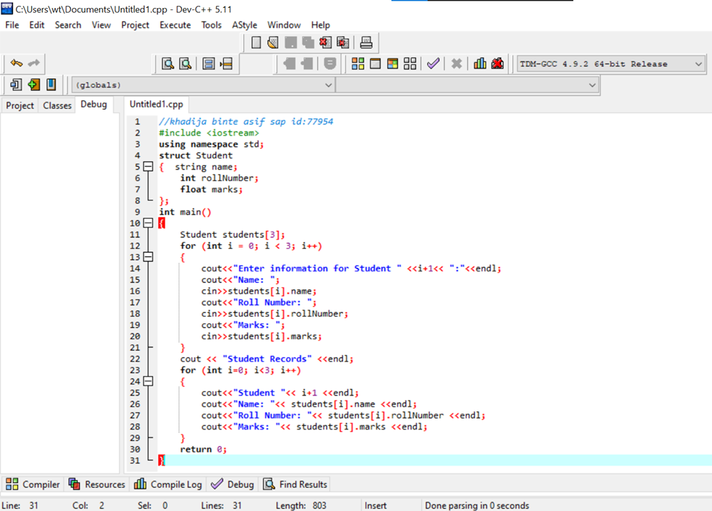

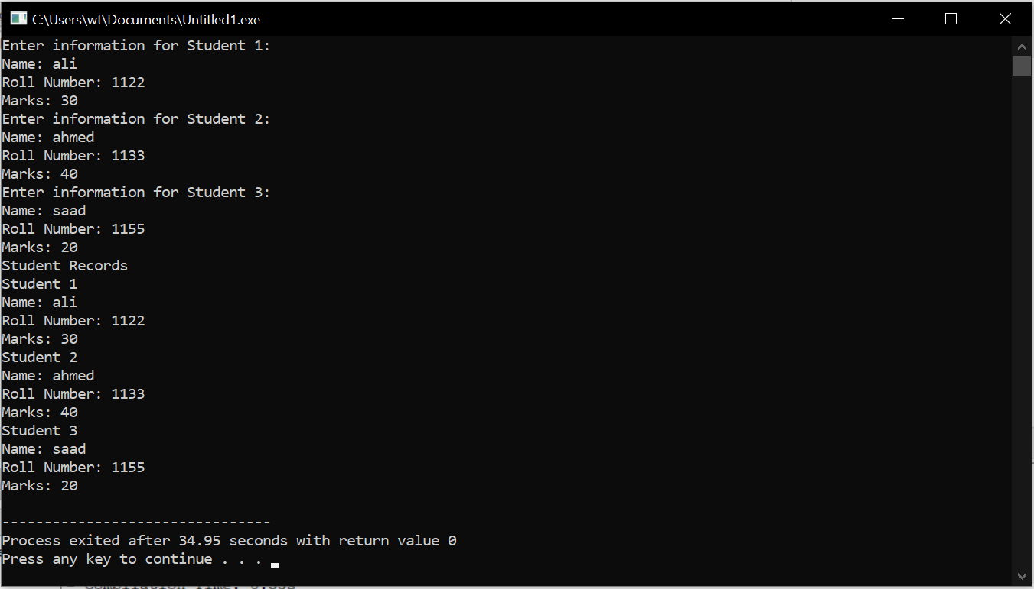

Lab Task 3 — Check Number
Write a C++ program that asks the user to enter a number and checks whether the number is positive, negative, or zero. Use appropriate conditional statements to make the decision and display the result
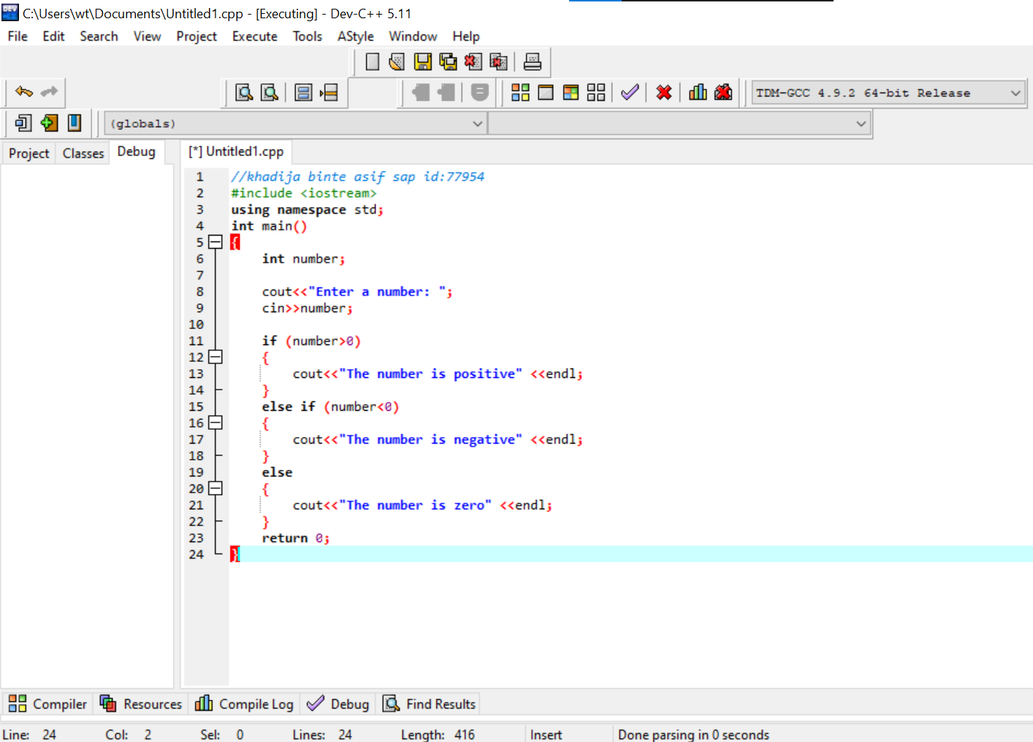

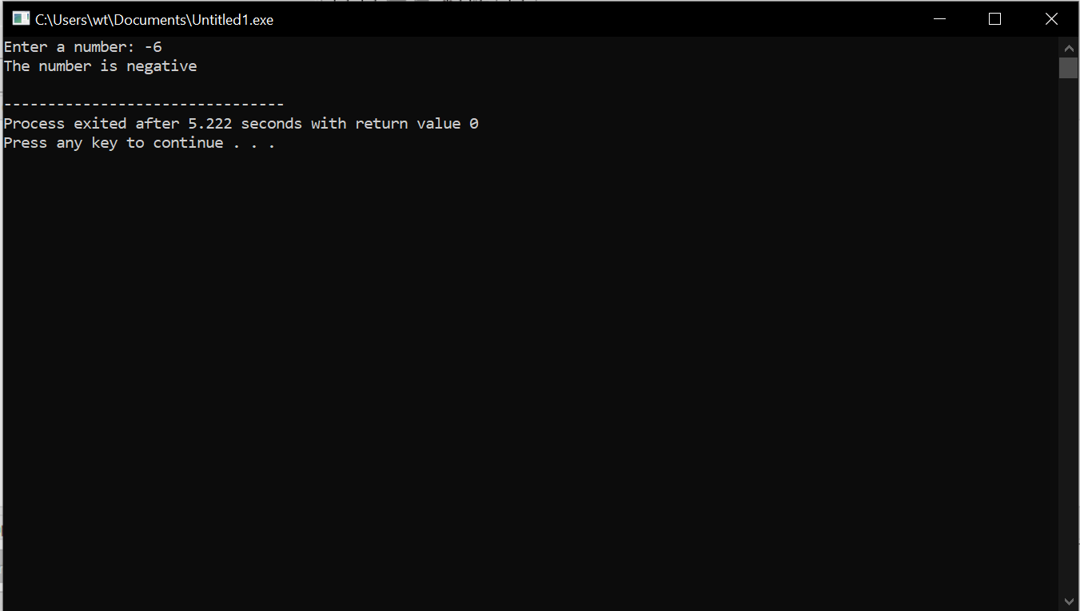

Lab Task 4 — Find Maximum
Write a C++ program that stores five integers in an array and creates a function int findMaximum(int arr[], int size) to find and return the largest element in the array. In main(), input the elements, call the function, and display the largest number.


